
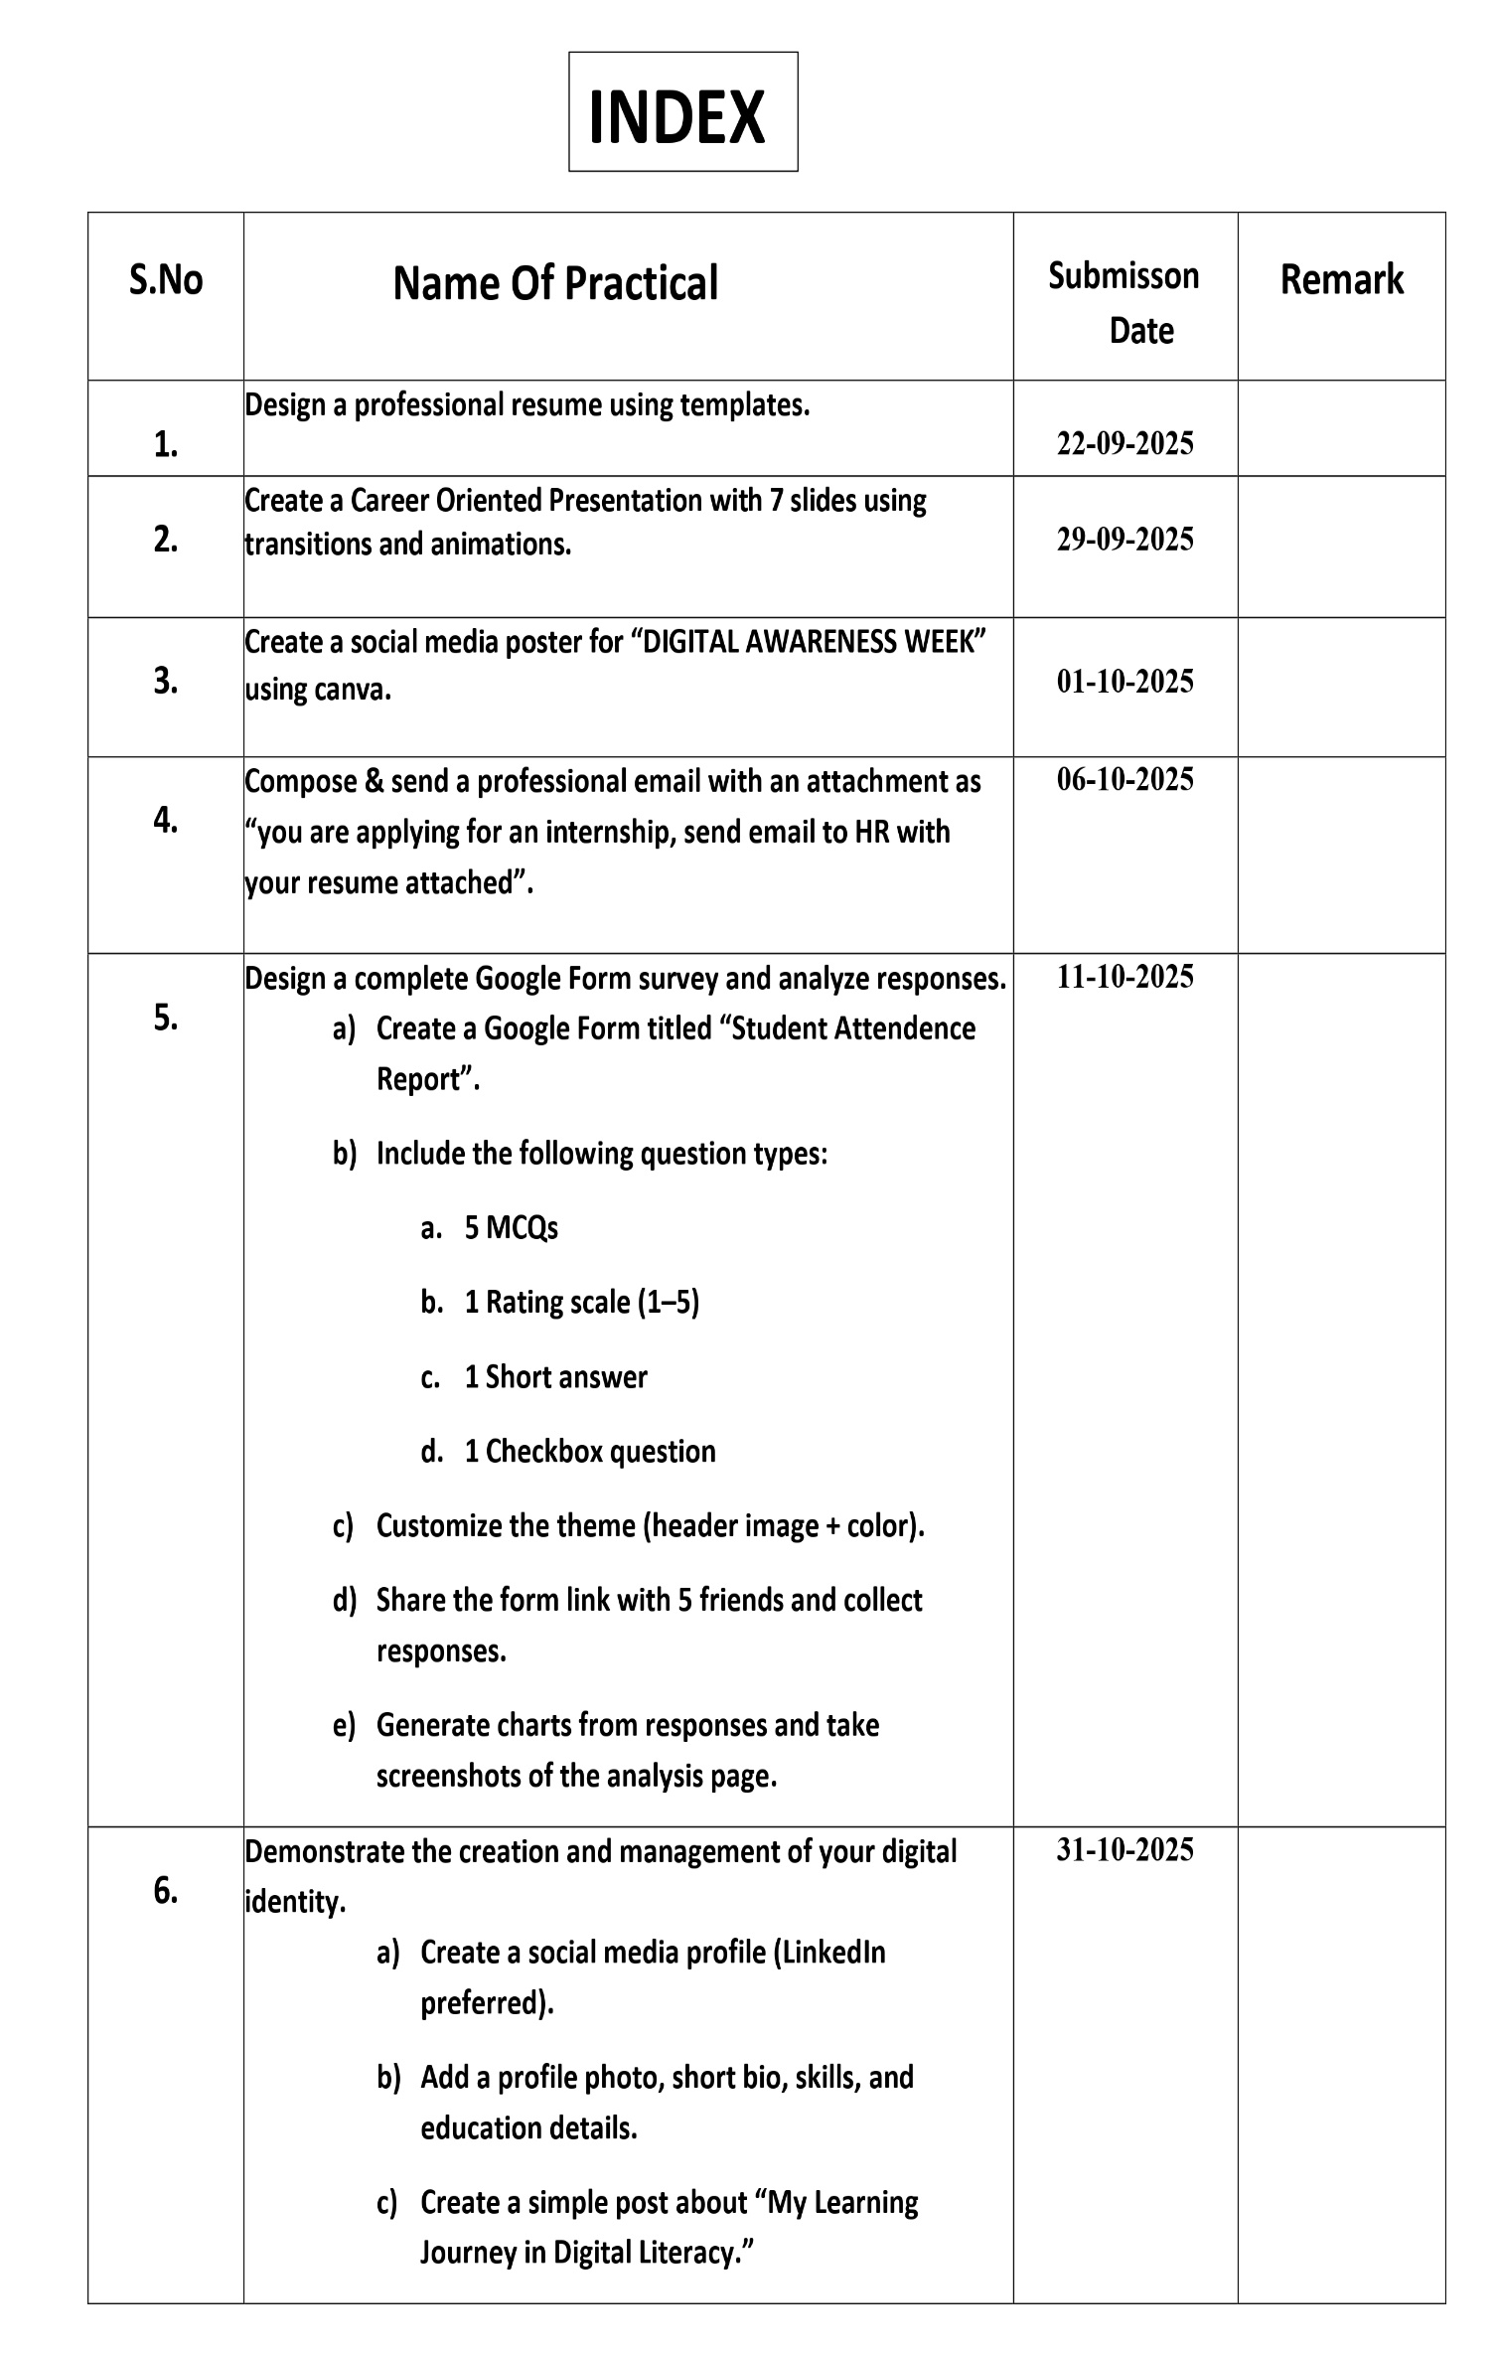
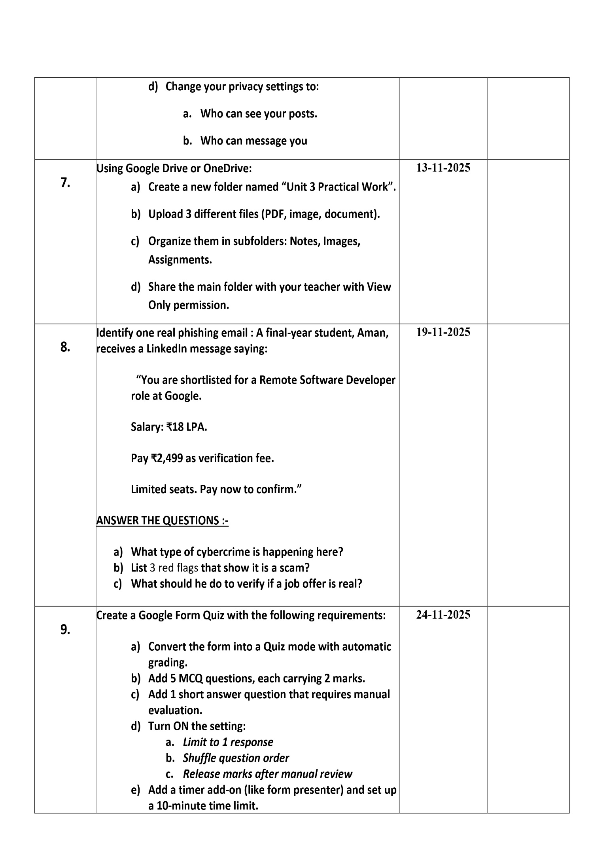
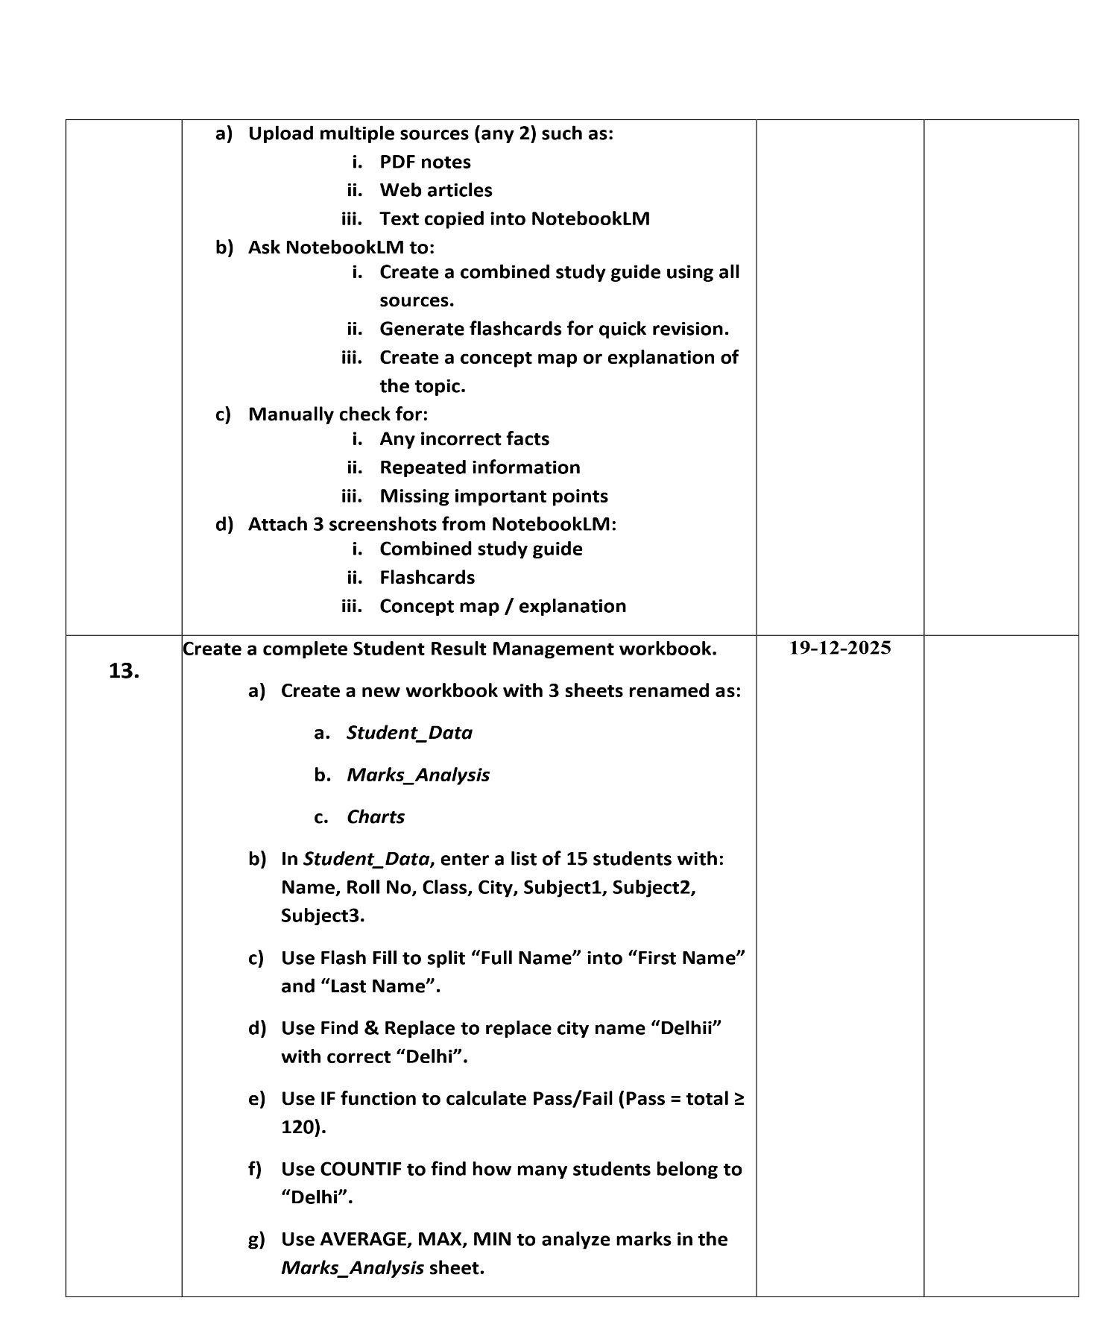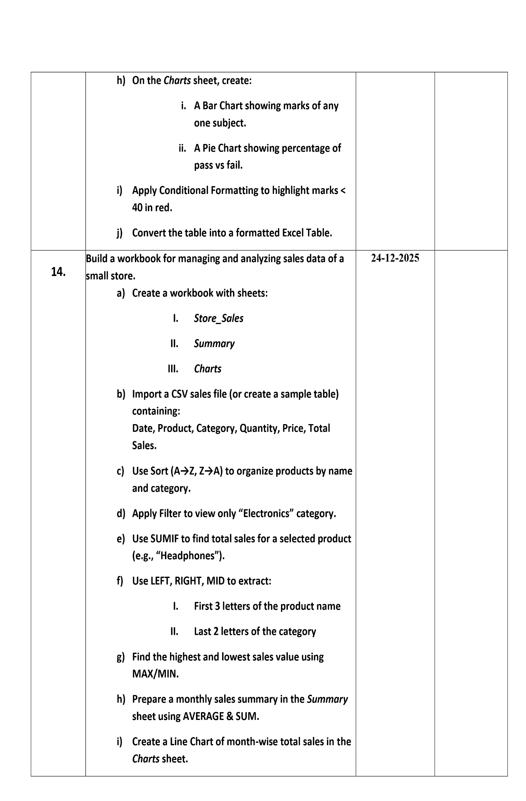
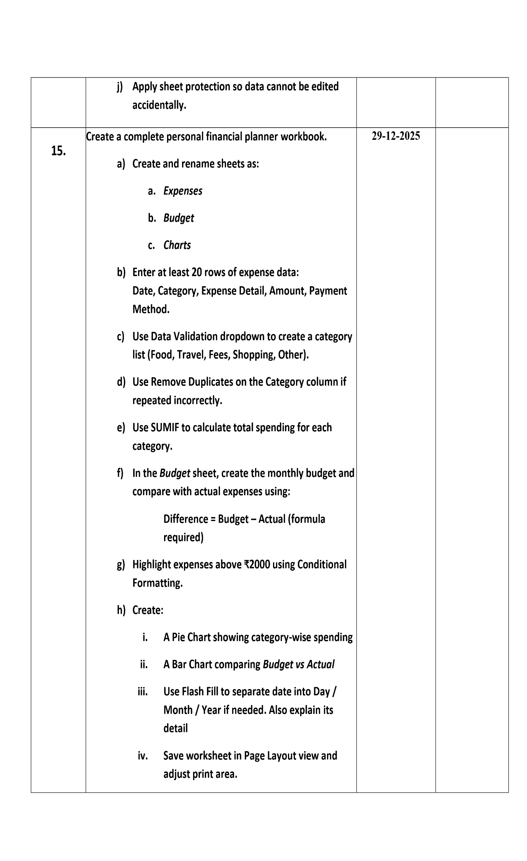

Practical 1: Design a Professional Resume

Aim - To design a professional resume using online templates.

Objectives
- To understand professional formatting of resumes
- To identify key resume components
- To export resume in PDF format

Procedure

Open the Resume-Designing Application
Start by launching Canva, Google Docs, or MS Word on your computer.

○ If using Canva, log in with your account and go to the Templates section.

○ If using Google Docs, open a new document through Google Drive.

○ If using MS Word, open the application and select “New
Document.”

1. Browse and Select an Appropriate Resume Template Navigate to the resume template section. Browse through various designs and choose a template that matches a professional look, preferably clean, simple, and easy to read.

○ Canva offers a wide range of modern templates.

○ Google Docs provides basic but neat resume layouts.

○ MS Word includes both modern and classic templates.

2. Enter Personal Information
Replace the sample text in the template with your personal details, such as:

○ Full Name

○ Contact Number

○ Email Address

○ Address (optional)

○ LinkedIn or portfolio links (if applicable) Ensure the information is accurate and formatted consistently.

3. Add Academic Details
Insert your educational background in the provided section of the template. Include:

○ Course/Program Name

○ Institution Name

○ Duration (Year of study)

○ Grades or CGPA (if required)
Arrange information in reverse chronological order (most recent first).

4. Write a Career Objective
Add a short, clear career objective highlighting your goals, strengths, and professional aspirations.
Keep it concise (2–3 lines) and tailored to the field you are applying for.

5. Include Skills and Achievements
Create a section for skills, both technical and soft skills.
Examples:

○ Technical skills (e.g., MS Office, programming languages)

○ Soft skills (e.g., communication, teamwork)
Add any academic achievements, certificates, awards, or projects relevant to your profile.

6. Format the Resume Professionally
Adjust the text formatting to ensure clarity and readability:

○ Use headings for each section (e.g., Education, Skills, Objective).

○ Use bullet points to list items cleanly.

○ Maintain consistent font style, size, and alignment throughout.

○ Ensure proper spacing and margins for a neat layout. Review the resume for grammatical correctness and visual balance.

7. Preview and Make Final Adjustments
Scroll through the entire resume to check layout alignment, spacing, colors, and text placement.
Make sure the document looks uniform and professional before exporting.

8. Export the Resume in PDF Format
Once the final layout is ready, export or download the document as a PDF file, which preserves formatting.

○ In Canva, click Download → PDF Print.

○ In Google Docs, go to File → Download → PDF Document.

○ In MS Word, select File → Save As → PDF.

Output –

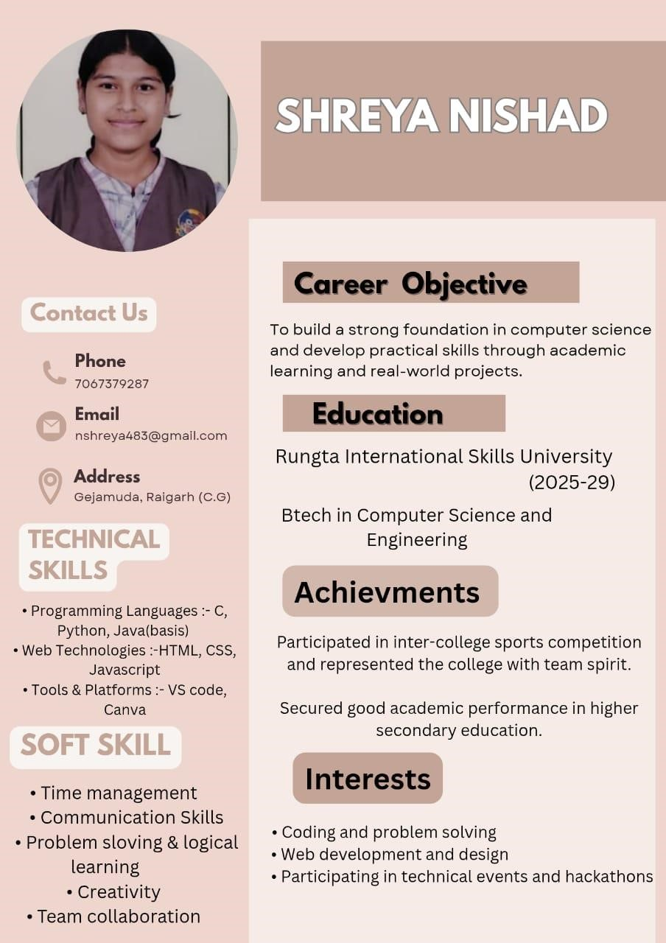

Practical 2: Career-Oriented Presentation

Aim - To create a career presentation using slides, transitions, and animations.

Objectives
- To design a multi-slide professional presentation
- To apply transitions and animations

Procedure

Open a blank presentation
Launch PowerPoint/Google Slides and select the option to create a new blank presentation.
This opens a fresh workspace where you will design your slides.

Create a title slide
Insert a title slide layout and add the presentation title along with your name or subtitle.
Ensure the title is clear, readable, and visually centered on the slide.

Add minimum 7 slides
Use the “New Slide” option to insert at least seven additional slides with appropriate layouts.
Each slide should focus on a single topic or idea for clarity.

Insert images, icons, and bullet points
Add relevant images and icons to visually support your content.
Use bullet points to present information in a structured and easy-to read format.

Apply a theme
Choose a professional theme from the design options available in the software.
The theme will automatically set consistent fonts, colors, and backgrounds.

Add transitions and animations
Apply slide transitions for smooth movement between slides. Add animations to text or images to enhance the presentation without overusing effects.

Output :-


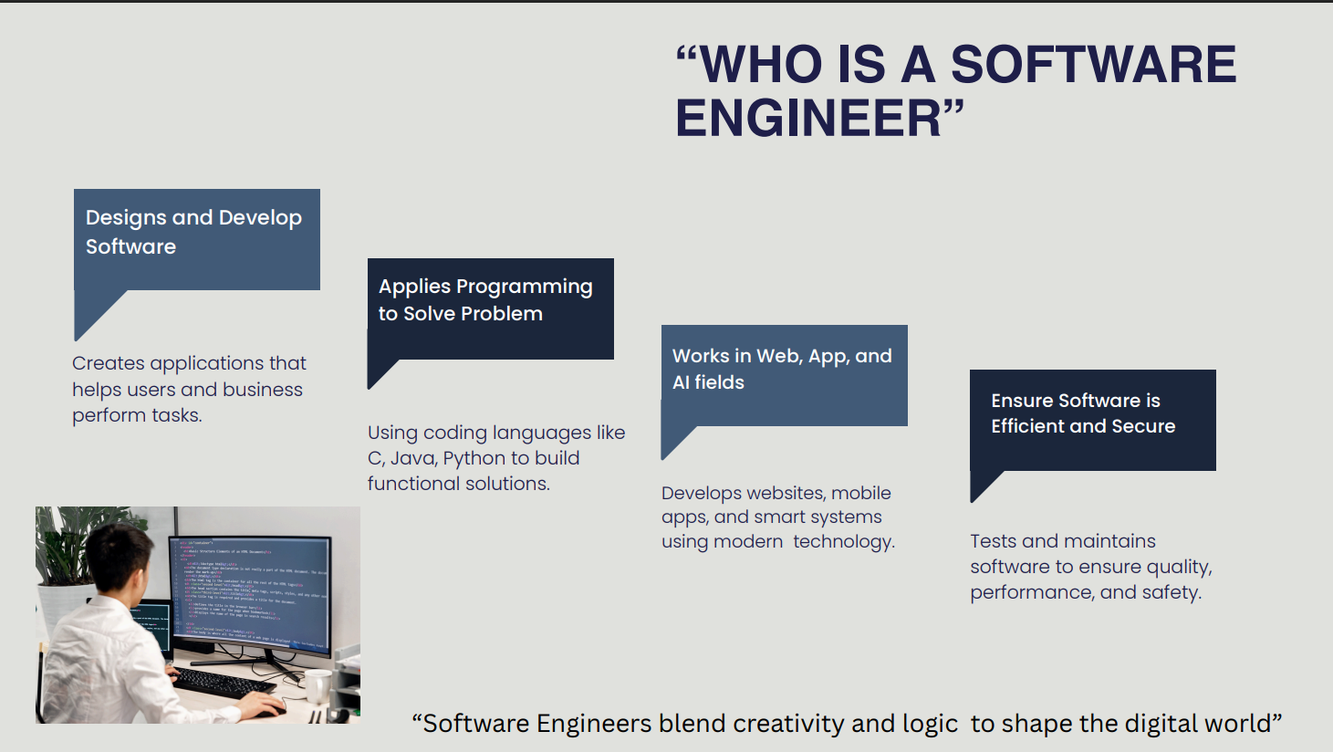

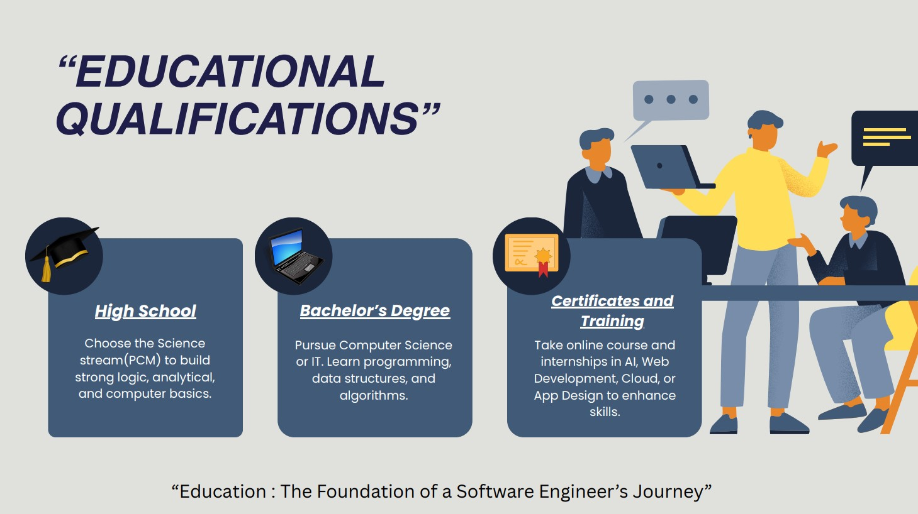

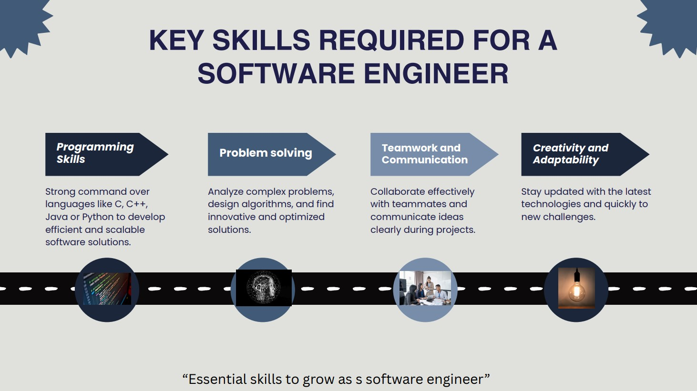

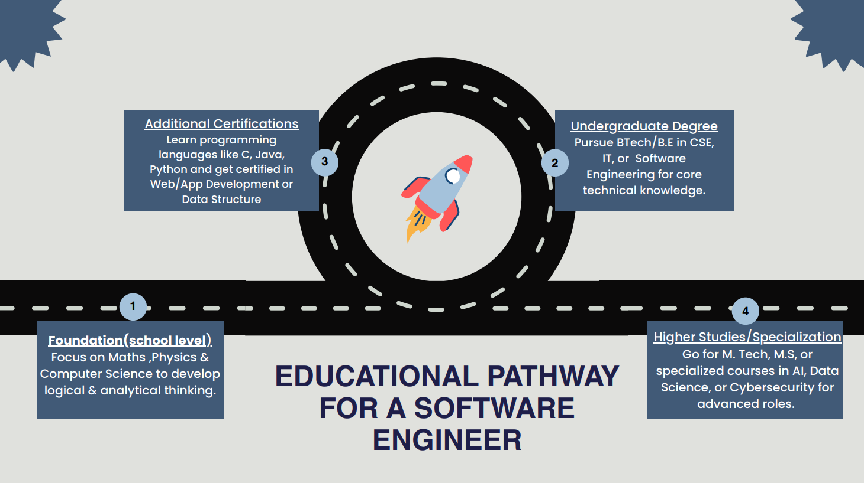
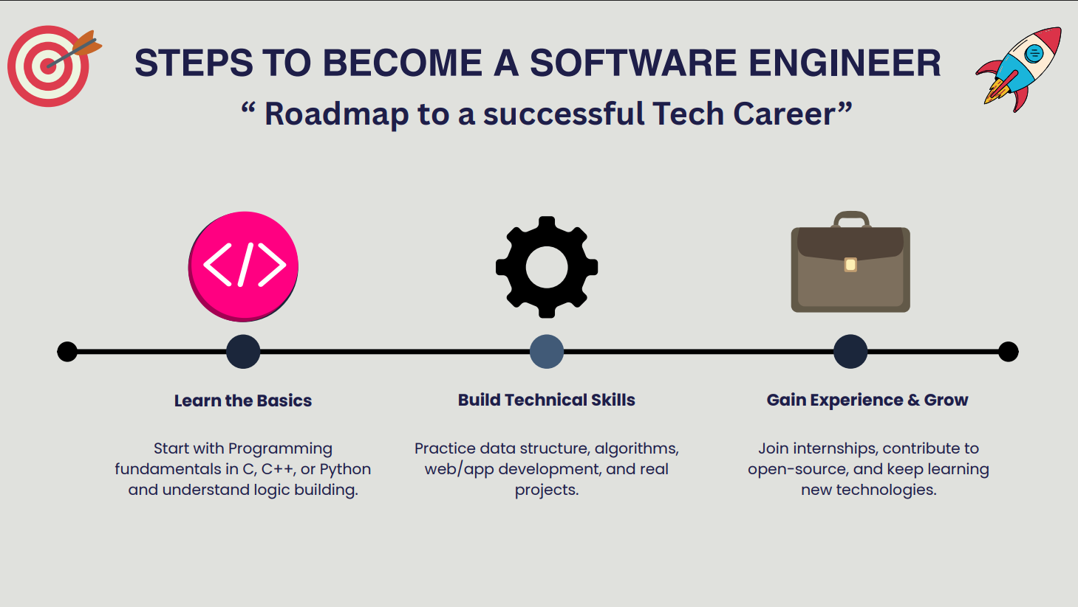

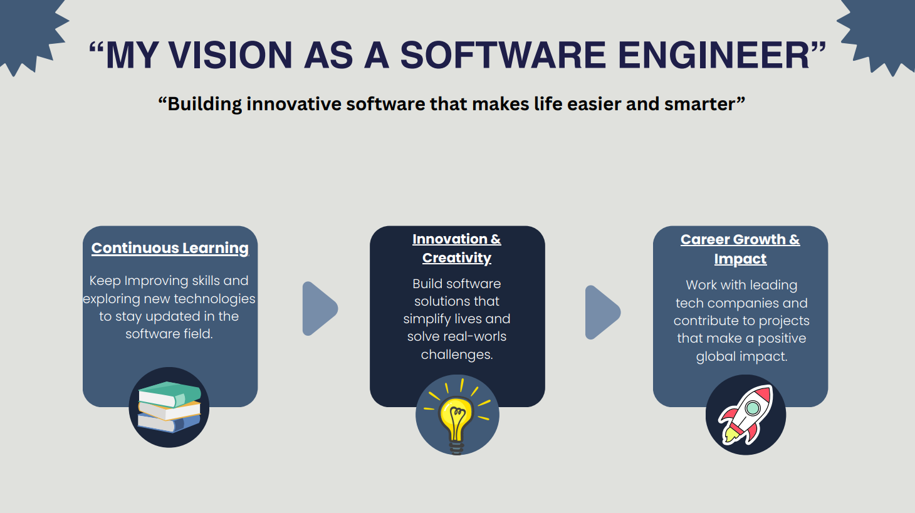

Practical 3: Digital Awareness Poster in Canva

Aim - To design a poster for Digital Awareness Week using Canva.

Objectives
- To apply design tools
- To create a visually appealing poster

Procedure

Login to Canva
Open Canva in your browser and sign in using your email or Google account.
This gives you access to all templates, design tools, and editing features.

Select poster layout

Search for “Poster” in the template section and choose a suitable layout.
This layout provides a ready-made design structure to begin your poster.

Add “Digital Awareness Week” text

Insert a text box or edit the existing heading and type “Digital Awareness Week.”
Adjust the font style, size, and alignment to make the title prominent.

Insert icons and graphics

Go to the “Elements” tab to add icons, shapes, and relevant graphics. Position them creatively to enhance the visual appeal and message of the poster.

Apply suitable colors

Choose a color theme that matches the topic and improves readability.
Use consistent color combinations for background, text, and elements.

Download final poster

Click the “Download” button and select the preferred file type, usually PNG or PDF.
Save the poster to your device for printing or sharing

Output :-

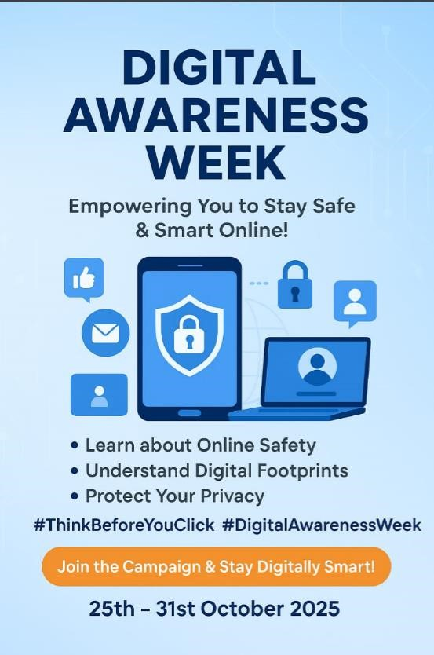

Practical 4: Professional Email (Internship Application)

Aim - To draft and send a professional internship email with attachment.

Objectives
- To compose a professional email
- To attach documents

Procedure

Open Gmail
Go to the Gmail website or app and log in with your email account. This opens your inbox where you can create and send emails.

Click Compose
Select the “Compose” button to open a new email window.
A blank message box will appear on the screen.

Write subject line
Enter a clear and concise subject that reflects the purpose of the email.
This helps the recipient understand the message at a glance.

Write professional message
Type a polite, well-structured message addressing the recipient formally.
Keep the tone respectful and include necessary details or requests.

Attach resume
Click the attachment (paperclip) icon and select your resume file from your device.
Ensure the resume is in PDF format and properly named.

Send email
Review the email for accuracy and ensure attachments are included.
Click “Send” to deliver the message to the recipient

Output :-

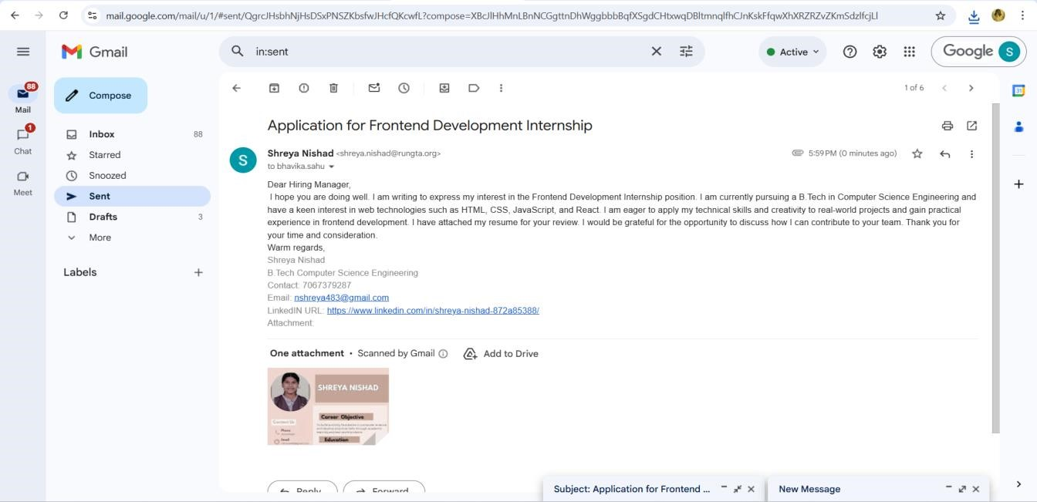

Practical 5: Create Google Form – Attendance Report

Aim - To design a Google Form and analyze responses.

Objectives
- To create form with multiple question types
- To collect sample responses
- To analyze responses

Procedure

Create new Google Form
Open Google Forms from your Google account and click “Blank Form” to start a new form.
This opens an empty form where you can add questions.

Title it “Student Attendance Report”
Enter the title at the top of the form and add a short description if needed.
This helps respondents understand the purpose of the form.

Add MCQs, rating, checkbox and short answer
Use the question type menu to insert multiple-choice questions, rating scales, checkboxes, and short-answer fields.
Arrange the questions in a logical order for easy response.

Customize theme
Click the Theme icon to change colors, fonts, and header images.
This improves the appearance and makes the form visually appealing.

Share form and collect responses
Use the Send button to share the form via link, email, or QR code. Allow participants to submit their responses through any device.

View summary charts
Go to the Responses tab to see automatic charts and graphs generated by Google Forms.
These visual summaries help you quickly analyze the collected data.

Take screenshots
Capture screenshots of the form, responses, and charts for documentation.
Save them for use in reports or practical records.

Output :-
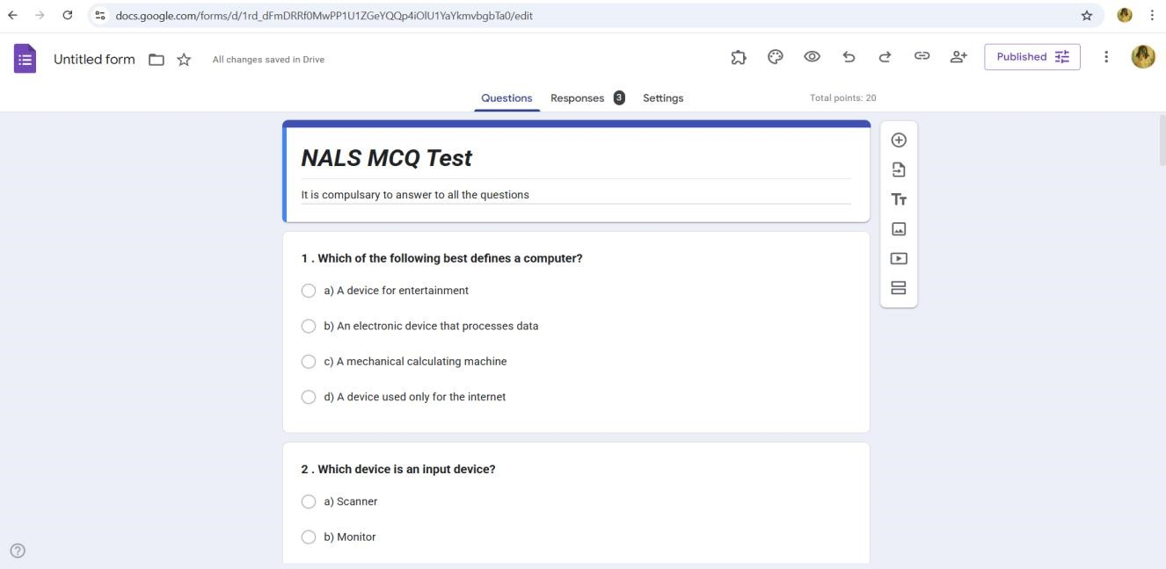

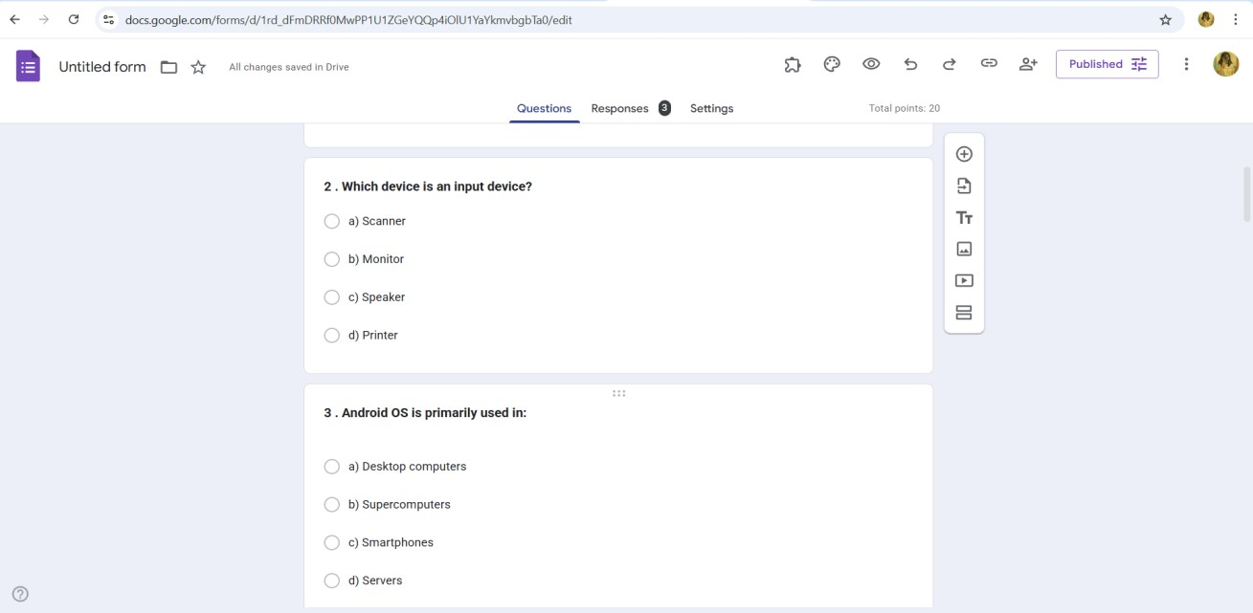
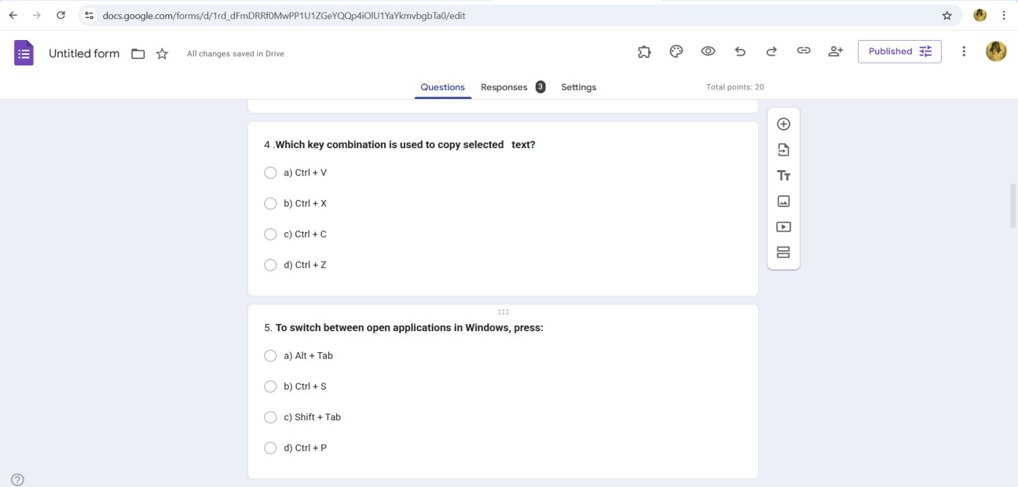

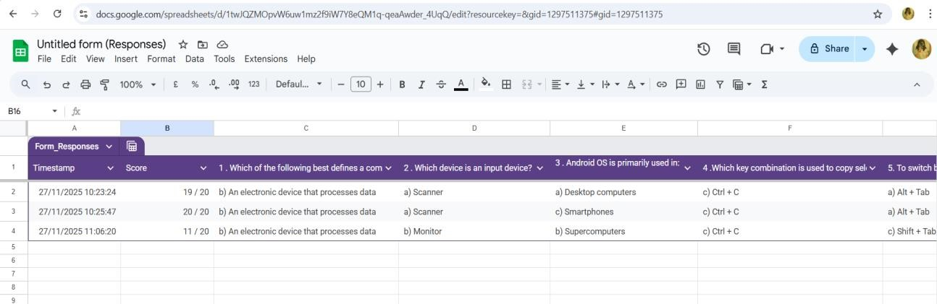

Practical 6: Create Digital Identity – LinkedIn

Aim - To create and modify digital identity using LinkedIn.

Objectives
• To create professional online profile
• To update personal information

Procedure

Create LinkedIn profile
Sign up on LinkedIn using your email and set up a new profile.
This gives you access to professional networking and career-building tools.
Add photo, bio, education
Upload a clear professional photo and write a short bio summarizing who you are.
Enter your educational details to complete your basic profile information.
Add skills
Use the “Skills” section to list your technical and soft skills.
Adding relevant skills increases your visibility and strengthens your profile.
Create a simple post
Click “Start a Post” and write a short, meaningful update or introduction.
Share it publicly to begin engaging with your professional network.
Change privacy settings
Go to Settings & Privacy to adjust what others can see on your profile.
Modify visibility, contact preferences, and data-sharing options as needed.

Ouput :-

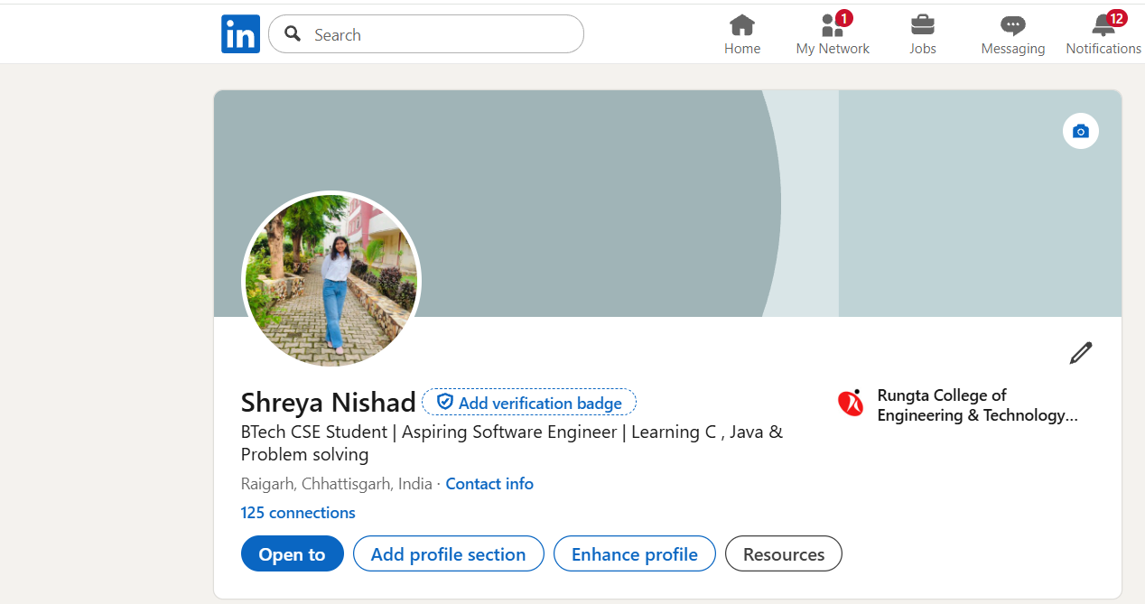

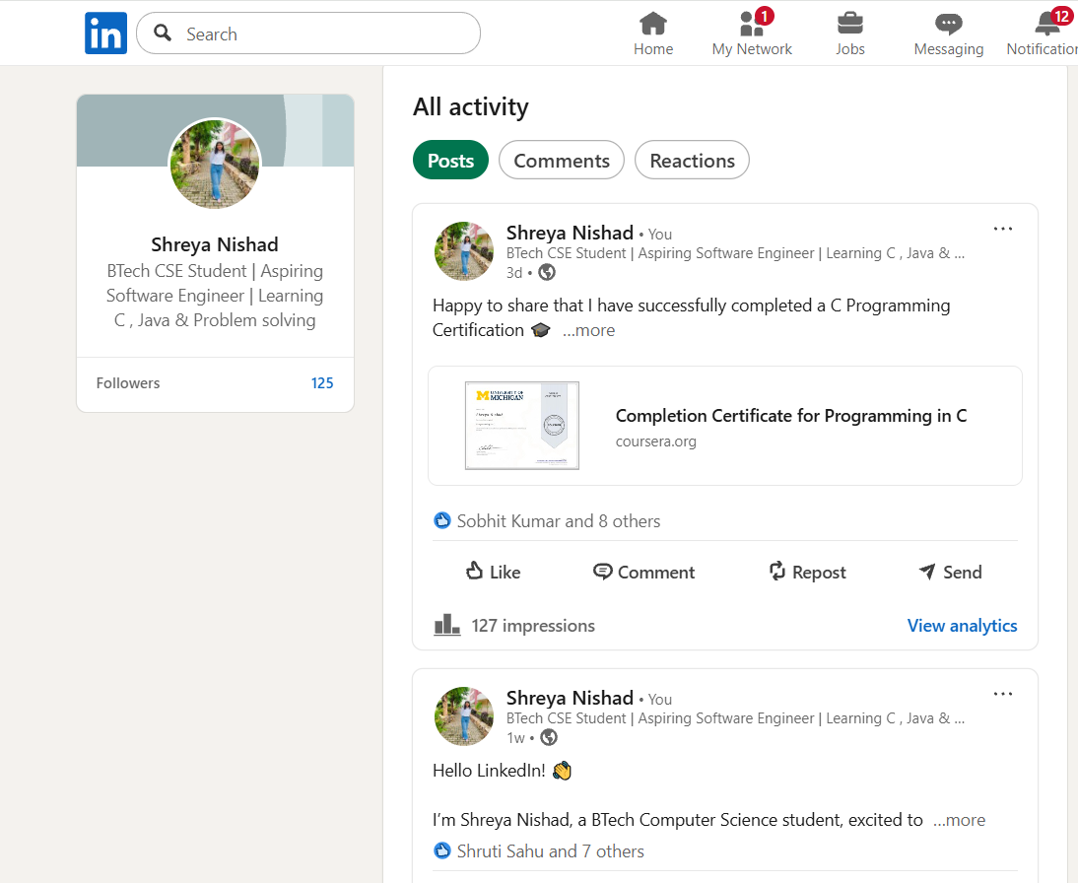

Practical 7: Using Google Drive / OneDrive

Aim - To upload and organize files in cloud storage.

Objectives
• To manage files online
• To share files securely

Procedure

- Create folder “Unit 3 Practical Work”
Open Google Drive or your file manager and create a new folder named “Unit 3 Practical Work.”
This folder will store all files related to the practical.
- Upload documents
Click the Upload option and select the required documents from your device.
The files will be saved inside the main folder for easy access.
- Create subfolders
Inside the main folder, create additional subfolders to categorize your documents.
This helps keep your work organized and easy to locate.
- Share main folder with View only
Right-click the folder, choose Share, and set the permission to View only for others.
This allows people to see the contents but prevents them from editing or deleting files.

Ouput :-

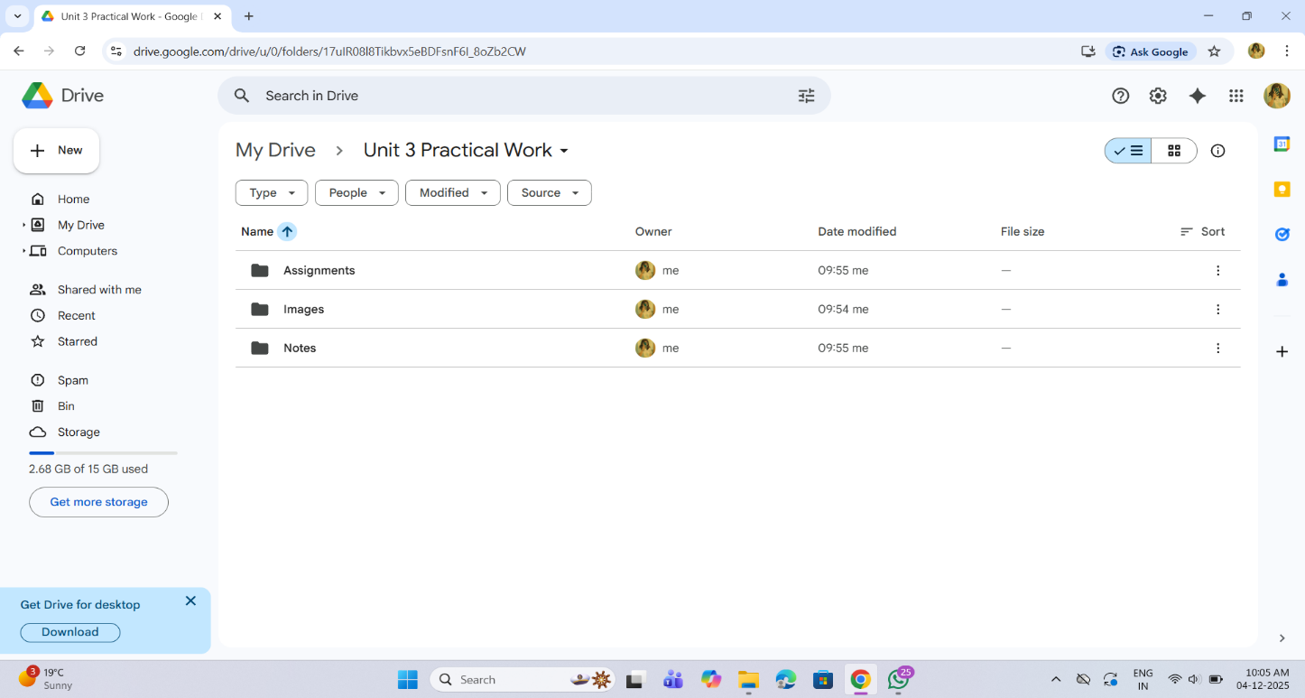

Practical 8: Identify Phishing Attack

Aim - To identify phishing attempts through digital messages.

Objectives
• To detect cybercrime
• To recognize scam elements

Procedure

Read message text
Carefully go through the entire message to understand its content and intent.
Make note of any unusual requests or unfamiliar senders.
Identify suspicious elements
Look for spelling errors, urgent demands, unknown links, or too-good-to-be-true offers.
These signs often indicate potential scams or malicious intent.
List cybercrime type
Based on the suspicious elements, categorize the message as phishing, fraud, malware attempt, etc.
This helps in understanding the nature and threat level of the cybercrime.
Write verification steps
Suggest ways to confirm authenticity, such as checking the sender’s email, contacting the official source, or scanning links.
These steps help prevent falling victim to cyberattacks.

Aim: Identify one real phishing email:
A final-year student, Aman, receives a LinkedIn message saying:
“You are shortlisted for a Remote Software Developer role at Google.
Salary: ₹18 LPA.
Pay ₹2,499 as verification fee.
Limited seats. Pay now to confirm.”

ANSWER THE QUESTIONS:-

1. What type of cybercrime is happening here?
Ans) This is an example of a Phishing Scam / Fake Job Scam.
The attacker is trying to cheat the victim by offering a fake job and asking for money.

2 . List 3 red flags that show it is a scam.
Ans) 1) Asking for money for job verification (real companies never ask for payment).
2) Unrealistic salary offer (₹18 LPA for a remote job without an interview).
3) Urgency and pressure like “Limited seats” and “Pay now”.

3 . What should he do to verify if a job offer is real?
Ans) 1) Check the official Google Careers website.
2) Verify the sender’s email or LinkedIn profile.
3) Contact the company through official HR channels.
4) Never pay any money for job confirmation.

Practical 9: Google Form Quiz with Timer

Aim - To create a quiz with automatic grading and time limit.

Objectives
• To automate quiz assessment
• To use time limit add-on

Procedure

1. Create Google Form – Open Google Forms and start a new blank form to set up the structure of your activity.

2. Convert to quiz – Enable “Make this a quiz” in the settings so you can assign points and correct answers.

3. Add 5 MCQs + 1 short answer – Insert five multiple-choice questions and one short-answer question, customizing options and points.

4. Enable 1-response limit – Turn on “Limit to 1 response” so each user can submit the form only once.

5. Shuffle questions – Activate the shuffle feature to randomize the order of questions for every respondent.

6. Add timer add-on – Install a timer add-on from the Add-ons menu to set and control the quiz duration.

7. Send link – Use the “Send” button to generate and share the form link with participants.

Output :-

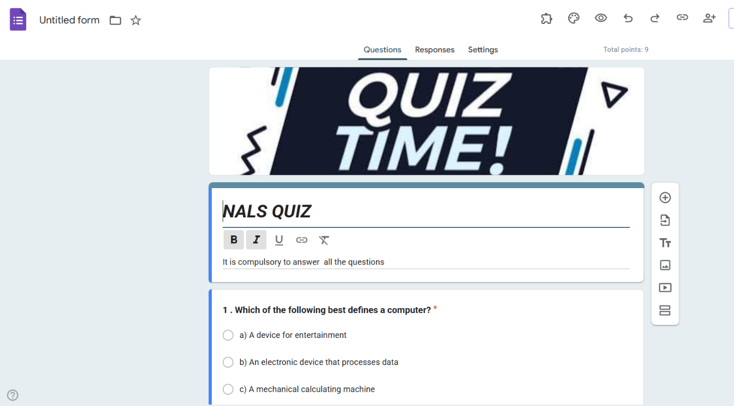

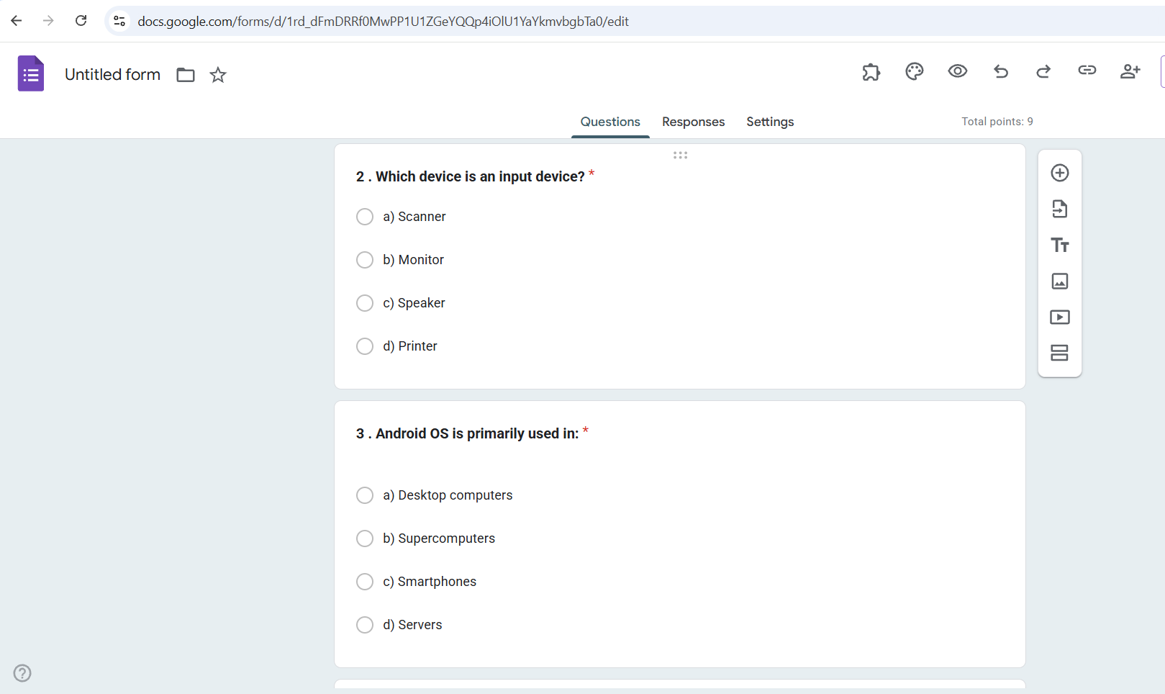

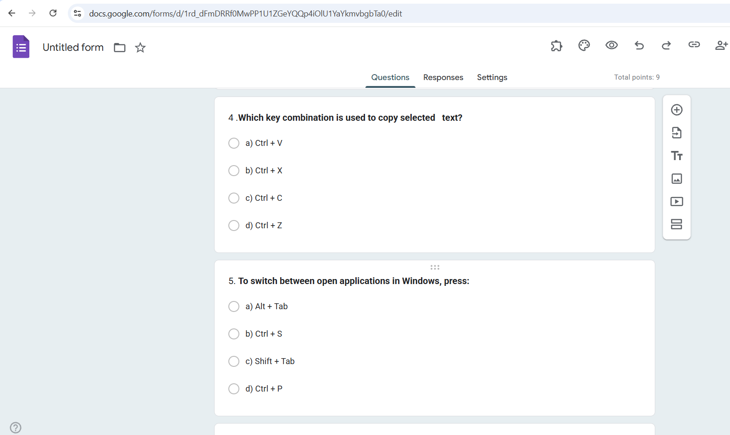

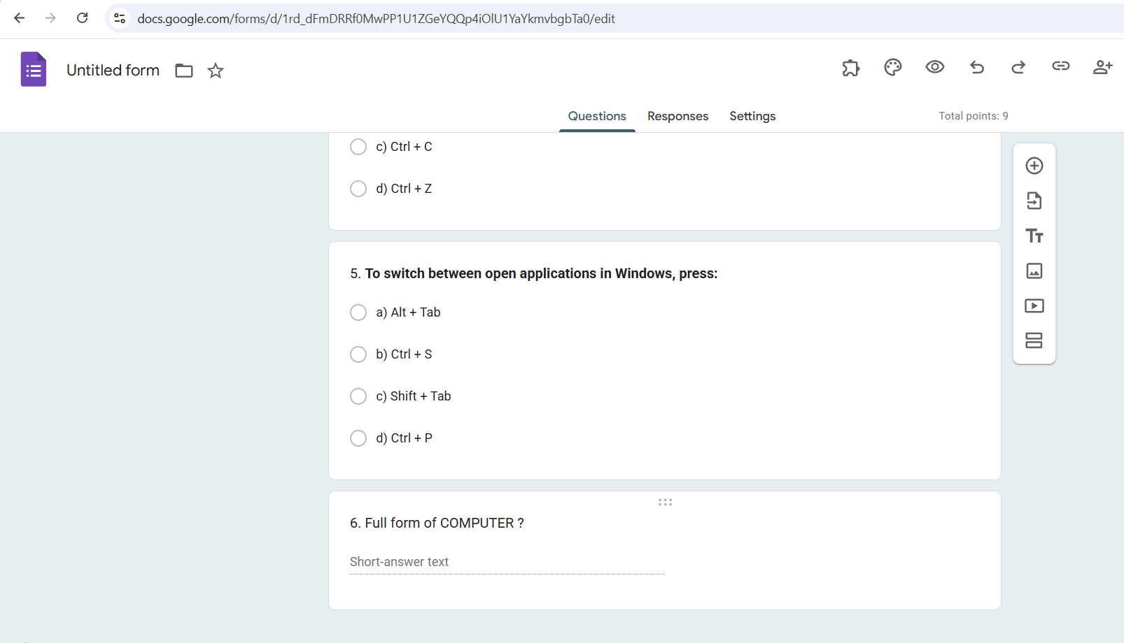

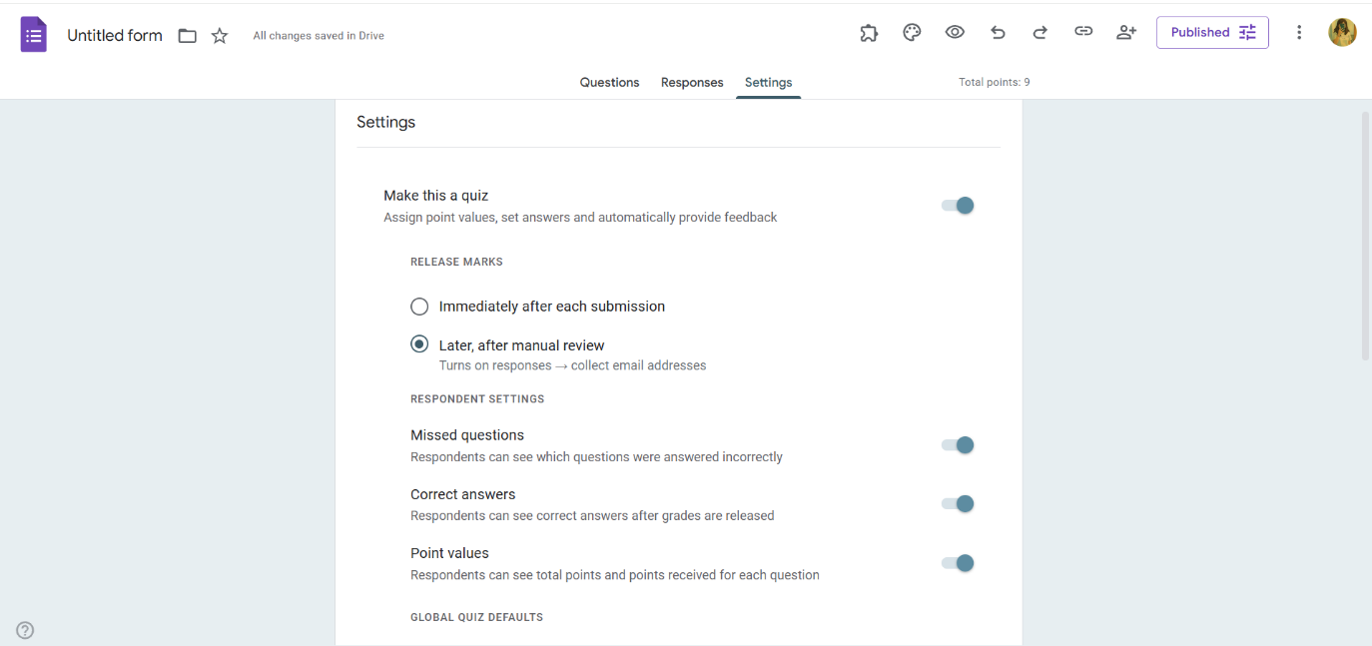

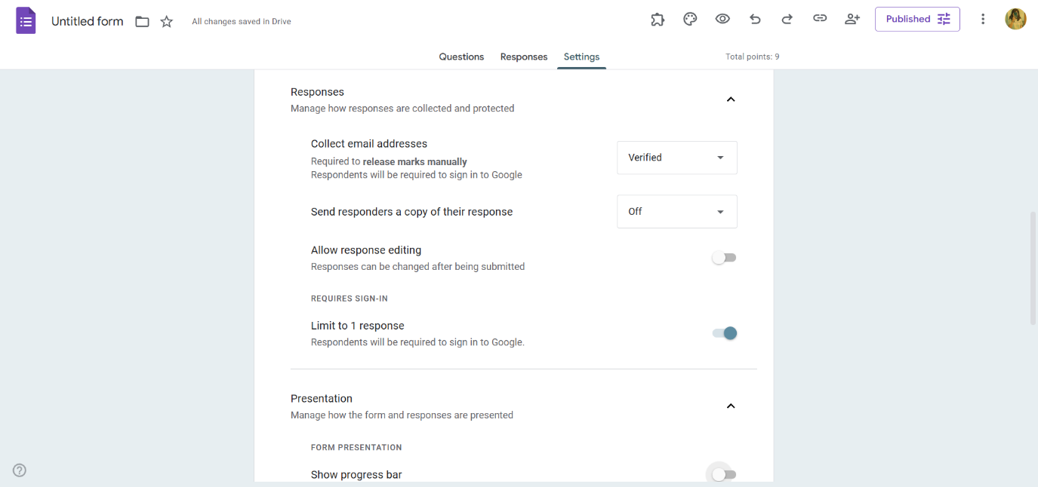

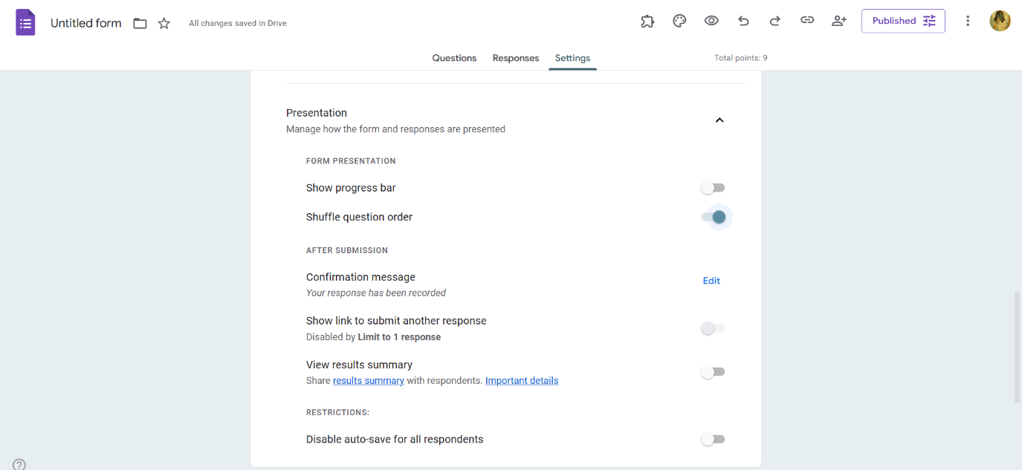

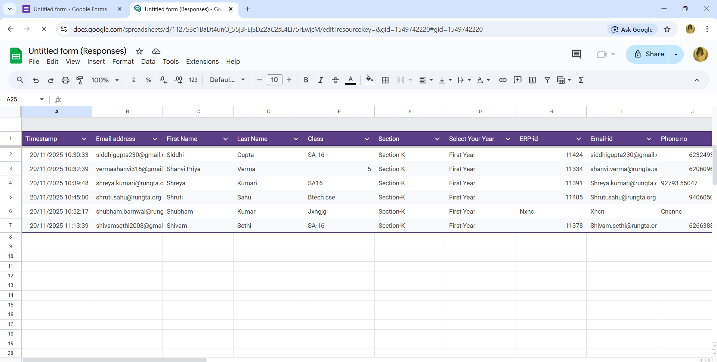

Practical 10: AI Text Bias & Plagiarism

Aim - To analyze AI generated text for plagiarism and bias.

Objectives
• To detect biased statements
• To improve writing

Procedure
1. Generate paragraph from AI – Use an AI writing tool to produce a clear, coherent paragraph on your chosen topic.

2. Check plagiarism – Run the paragraph through a plagiarism checker to ensure originality and proper attribution.

3. Check grammar – Review the text with a grammar tool to correct errors in punctuation, spelling, and sentence structure.

4. Identify biased statements – Examine the content for subjective language, assumptions, or one-sided viewpoints.

5. Rewrite neutrally – Revise the paragraph to remove bias, ensuring the tone is balanced, objective, and fact-based.

Output :-

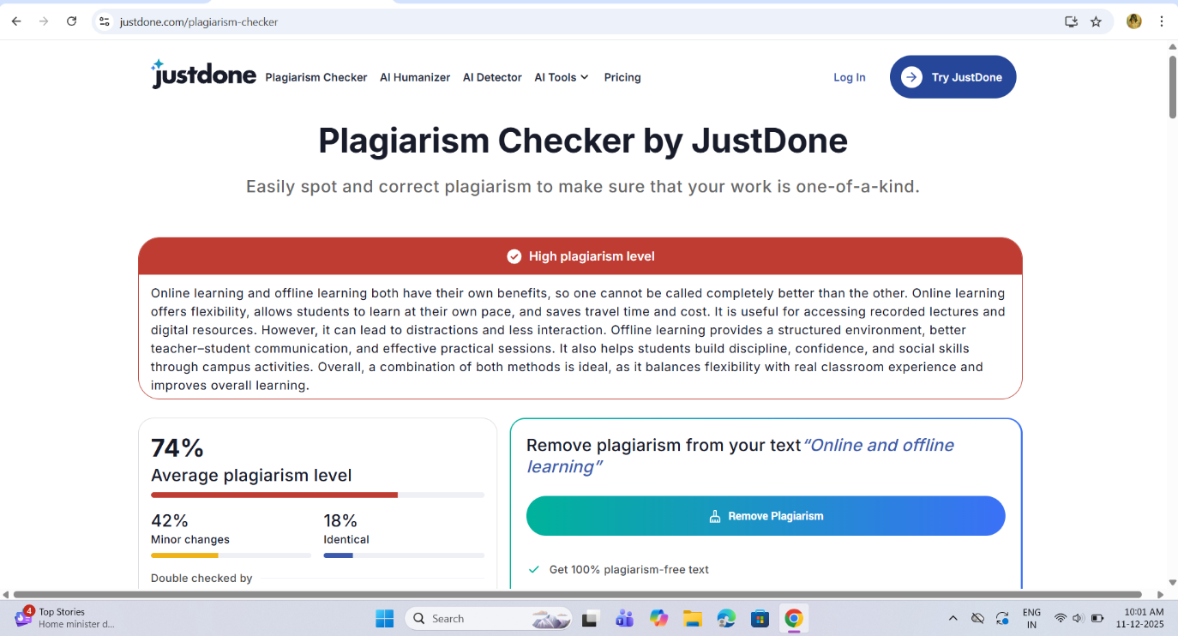

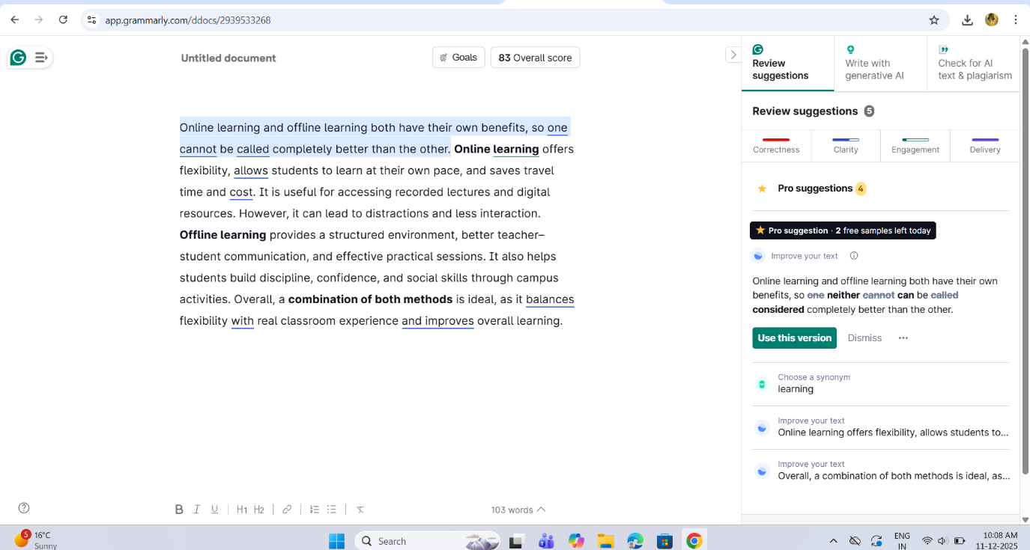

Biased Statements Found:
“Online learning is better for college students.” This is an over-generalization.
“Online classes offer flexibility and comfort for everyone.” Not true for all students.
“Offline learning is better for discipline.” One-sided opinion without evidence.

Rewritten Unbiased Paragraph:

Online and offline learning both have their own advantages for college students. Online learning provides flexibility and allows students to study from different locations, which is helpful for those with busy schedules. Offline learning, on the other hand, supports face-to-face interaction and practical activities that are important in many subjects. The effectiveness of each method depends on the student’s learning style, the subject being taught, and the learning environment. A balanced use of both methods can help students gain a better understanding and convenience. Online tools can support theory learning, while classroom teaching can enhance participation and hands-on experience.

Practical 11: Compare AI vs Human Writing

Aim - To compare AI-generated content with student-created content.

Objectives
•To identify difference in writing
•To understand AI limitations

Procedure

1. Write paragraph manually – Compose a paragraph yourself using your own ideas, wording, and structure on the selected topic.

2. Generate same topic using AI – Use an AI tool to produce another paragraph on the same topic for comparison.

3. Create comparison table – Organize both paragraphs side-by-side in a table to compare style, clarity, tone, and content differences.

Human-Generated Paragraph

Will AI Replace Jobs or Change Them?

Artificial Intelligence is becoming a major part of our daily lives, and many people are worried that it might replace human jobs. In my opinion, AI will not completely replace jobs but will definitely change the way people work. Some repetitive and simple tasks may be automated, which can reduce the need for manual labour. However, new types of jobs will also be created in areas like data analysis, programming, AI maintenance, and digital services. People will need to learn new skills to work with AI tools. Instead of taking away work, AI will make jobs faster, easier, and more efficient. Humans will still be needed for creativity, decision-making, and teamwork.

AI-Generated Paragraph

Artificial Intelligence is transforming industries by automating many tasks that were previously done by humans. While some jobs may be replaced, AI is more likely to change the nature of work rather than eliminate it completely. Routine activities such as data entry, basic customer support, and repetitive manufacturing can be handled efficiently by AI systems. However, new roles will emerge in fields like machine learning, robotics, cybersecurity, and AI supervision. Instead of removing opportunities, AI will help employees become more productive by reducing workload and improving accuracy. The future will involve humans and AI working together to achieve better results.

Limitation of AI :-

1. Lack of Human Intelligence
AI cannot think, reason, or understand like humans. It works only on predefined rules and data.

2. No Emotions or Creativity
AI has no emotions, feelings, or original creativity. It cannot make emotional or ethical decisions on its own.

3. Dependency on Data
AI systems require large amounts of accurate data. Poor or biased data leads to incorrect results.

4. High Cost of Development
Developing, training, and maintaining AI systems is expensive and requires advanced infrastructure.

5. Limited to Specific Tasks
AI is good at performing specific tasks but cannot perform multiple unrelated tasks like humans.

6. Lack of Common Sense
AI does not understand real-world situations or common sense unless explicitly programmed.

7. Job Displacement
Automation through AI can replace certain jobs, leading to unemployment in some sectors.

8. Security and Privacy Risks
AI systems can be misused for cybercrime, surveillance, or data privacy violations.

9. No Moral or Ethical Judgment
AI cannot judge what is morally right or wrong; it follows instructions without ethics.

10. Requires Human Supervision
AI systems still need humans for monitoring, updates, and decision validation.

Practical 12: NotebookLM Project

Aim - To create revision notes using NotebookLM.

Objectives
• To generate study guide
• To create flashcards

Procedure

1. Create NotebookLM project – Start a new project in NotebookLM to organize your materials and AI-generated outputs in one workspace.

2. Upload two resources – Add two documents or sources to the project so the AI can analyze and reference them.

3. Generate study guide – Use NotebookLM’s tools to create a structured study guide summarizing key concepts from the uploaded resources.

4. Generate flashcards – Automatically produce flashcards that highlight important facts, terms, or ideas for easier review.

5. Review accuracy – Carefully check the summaries and flashcards to ensure all information is correct and reflects the original resources.

6. Take screenshots – Capture screenshots of the study guide and flashcards to document your work or include them in your submission.

Output :-
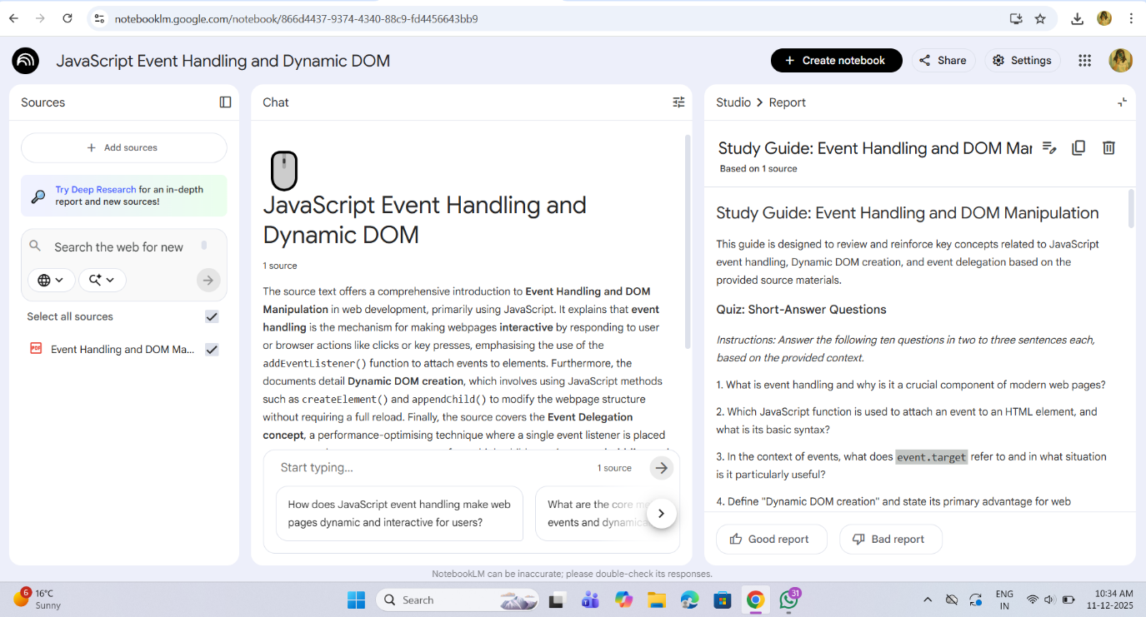

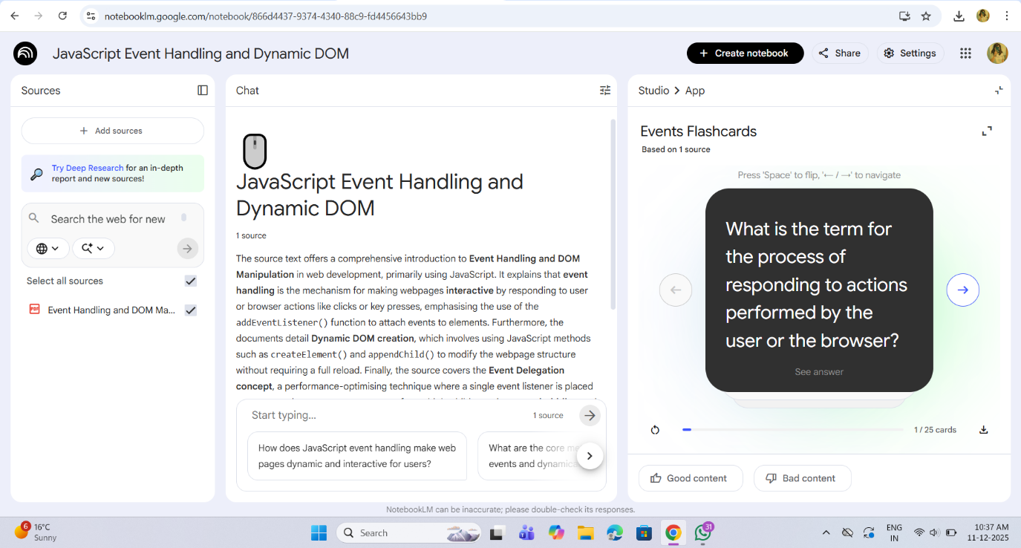

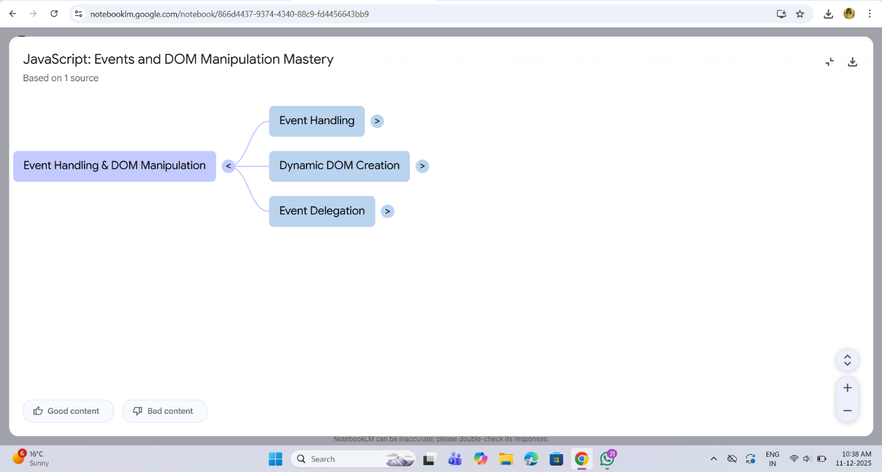

Practical 13: Excel Student Result Management

Aim - To analyze student marks using Excel tools.

Objectives
• To apply Excel formulas
• To create charts

Procedure

1. Enter student data – Input students’ names, marks, and other required details into the spreadsheet.

2. Use Flash Fill – Apply Flash Fill to automatically complete patterns such as separating names or formatting data.

3. Replace incorrect values – Identify errors and use Find & Replace or manual correction to fix inaccurate entries.

4. Calculate pass/fail using IF – Create an IF formula to determine whether each student passes or fails based on their score.

5. Use COUNTIF and AVERAGE – Apply COUNTIF to count specific results and AVERAGE to compute the class’s mean score.

6. Create charts – Generate visual charts to represent student performance trends or score distributions.

7. Apply conditional formatting – Use color-based formatting to highlight important values, such as low scores or top performers.

Output :-

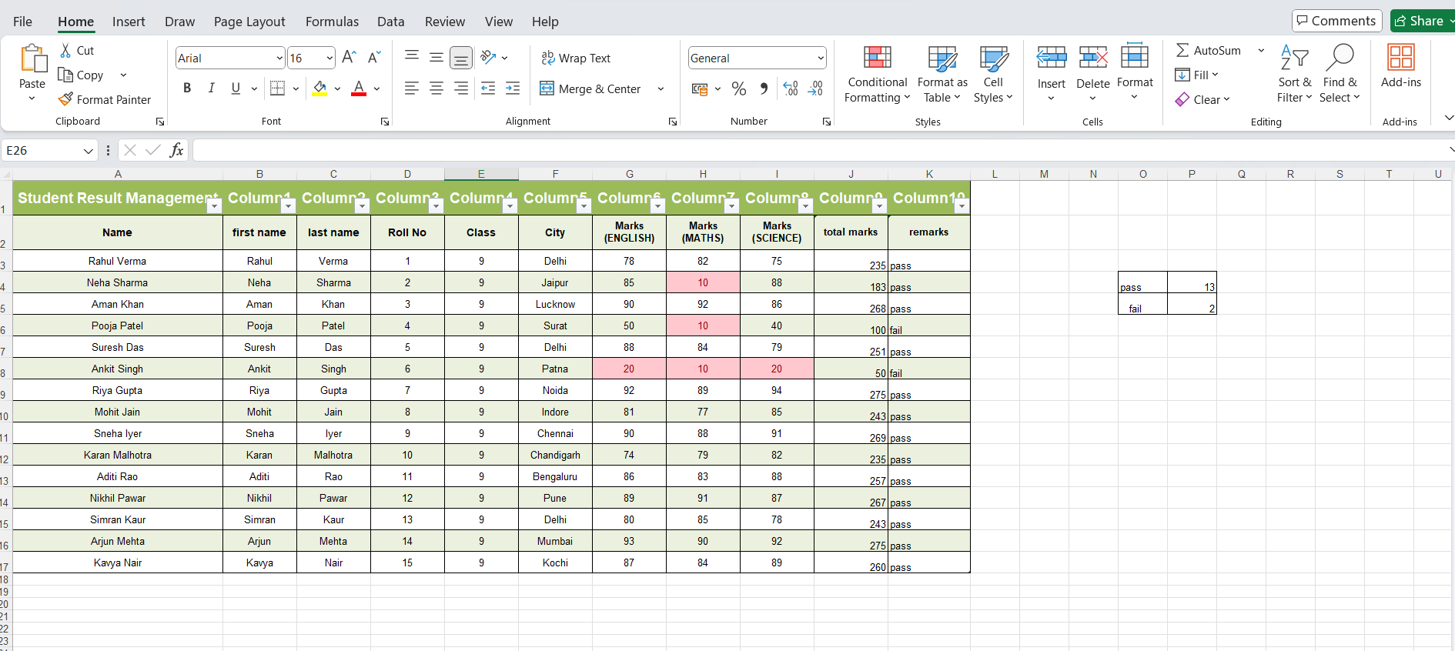

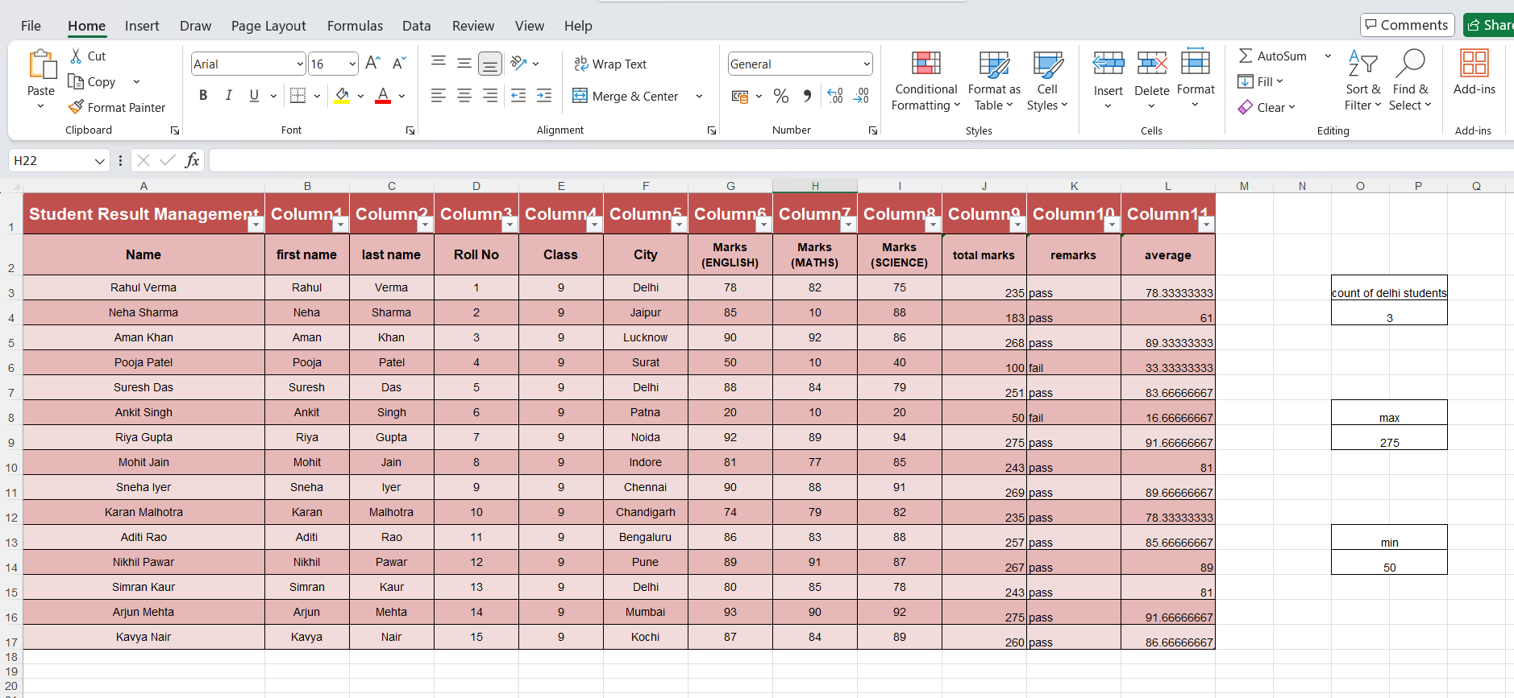

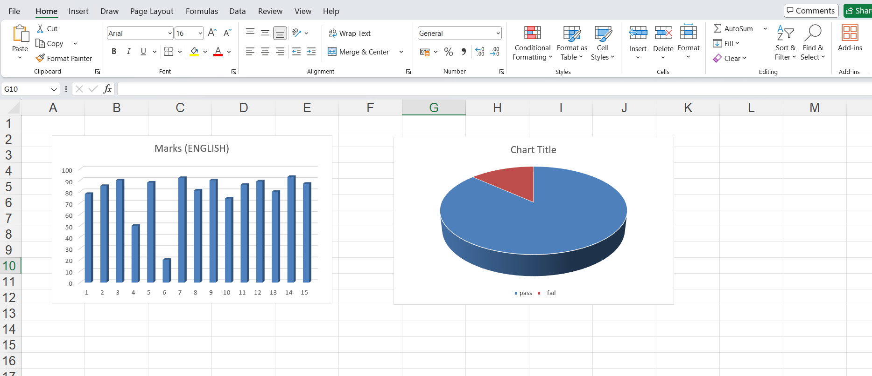

Practical 14: Sales Data Workbook

Aim - To analyze sales data using Excel formulas and charts.

Objectives
• To use SUMIF formulas
• To filter categories

Procedure

1. Enter or import sales data – Add sales records manually or import them from an external file to build your dataset.

2. Sort and filter – Organize the data by sorting and apply filters to focus on specific products, dates, or regions.

3. Use SUMIF – Apply the SUMIF function to total sales based on a chosen condition, such as product type or salesperson.

4. Extract text using LEFT/RIGHT – Use LEFT or RIGHT functions to pull specific characters from product codes or IDs.

5. Create line chart – Plot a line chart to visualize sales trends over time for clearer analysis.

6. Protect sheet – Lock the sheet or specific cells to prevent unauthorized edits and maintain data integrity.

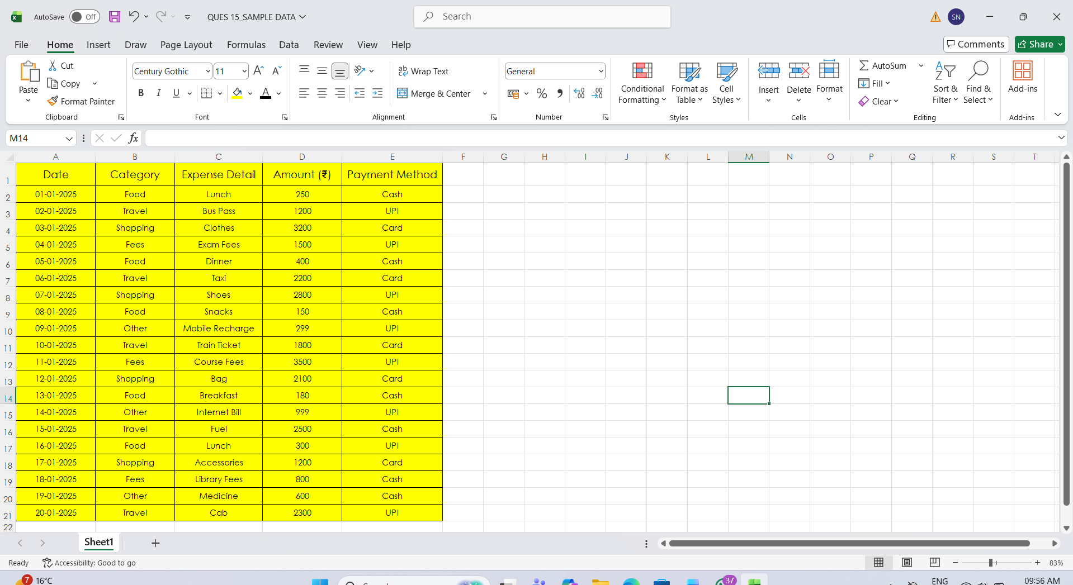

Practical 15: Personal Financial Planner

Aim - To prepare a personal financial planner using Excel.

Objectives
• To track expenses
• To compare budget vs actual

Procedure

1. Enter expenses – Record all expense items with their categories, dates, and amounts in the spreadsheet.

2. Apply Data Validation – Set validation rules to restrict inputs, such as allowing only numbers or predefined categories.

3. Use SUMIF – Use the SUMIF function to total expenses by category or any specific condition you choose.

4. Create budget sheet – Design a separate sheet comparing planned budgets to actual spending for better tracking.

5. Highlight expenses above limit – Apply conditional formatting to automatically mark entries that exceed your budget limit.

6. Create charts – Generate charts to visually present spending patterns, category breakdowns, or monthly totals.

7. Adjust print settings – Modify page layout, scaling, and margins to ensure the sheet prints clearly and fits on the page.

